What is Appiun

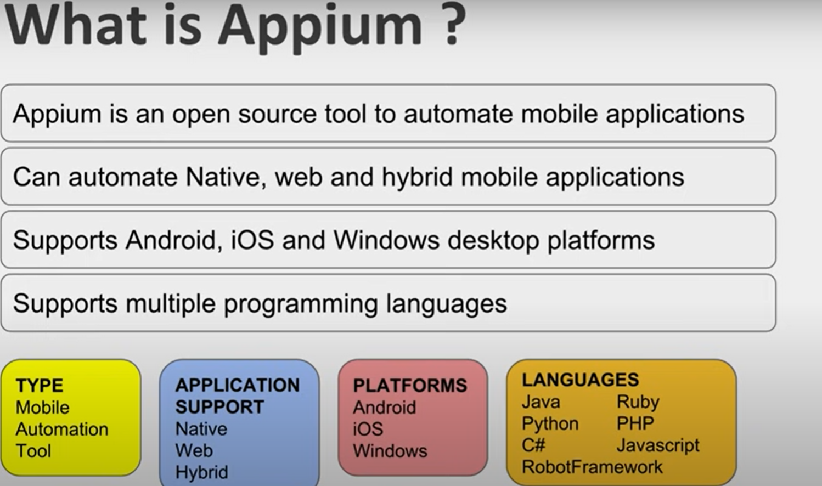



Types of mobile application

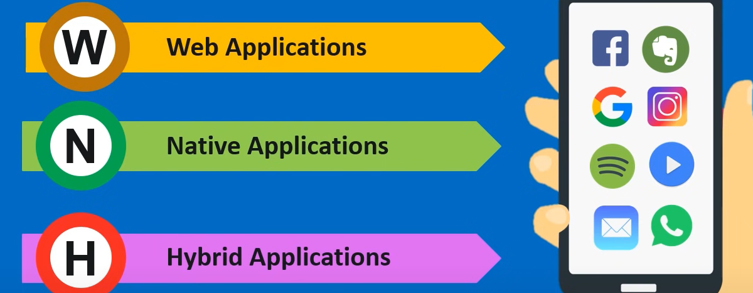

Web Application

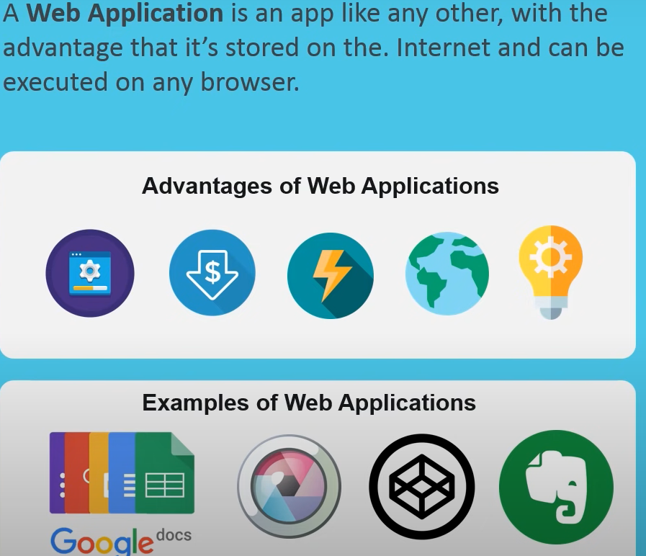

Native application

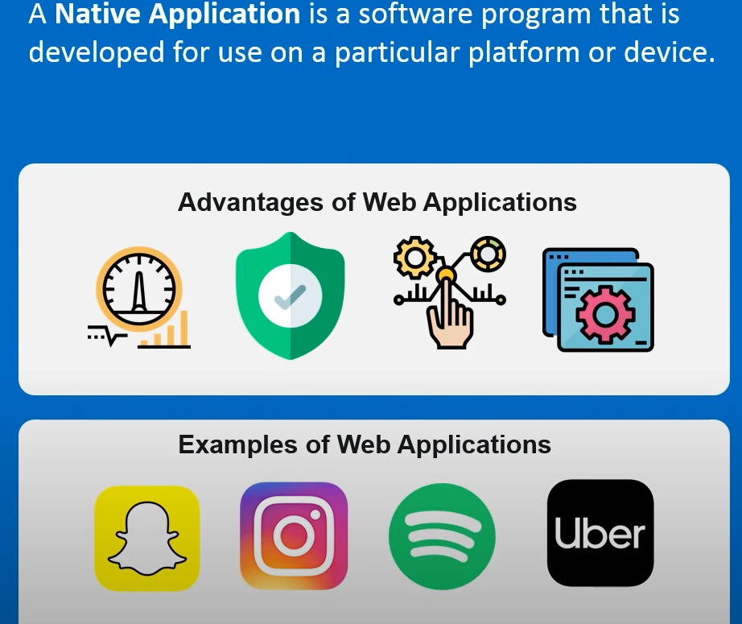

Hybrid application

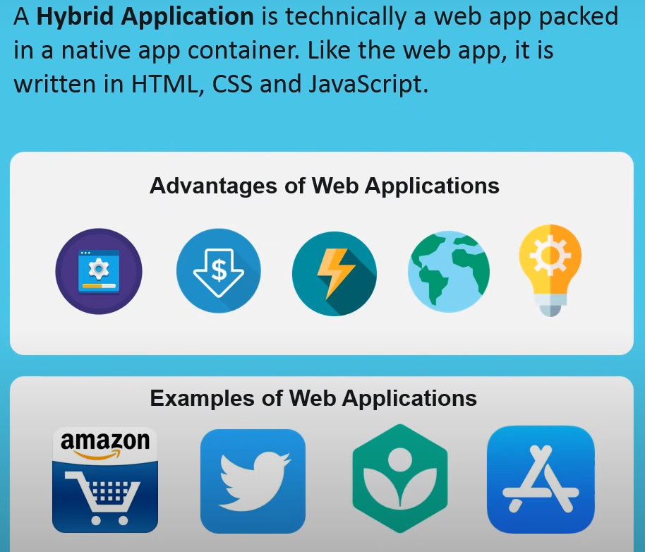

Why choose appium

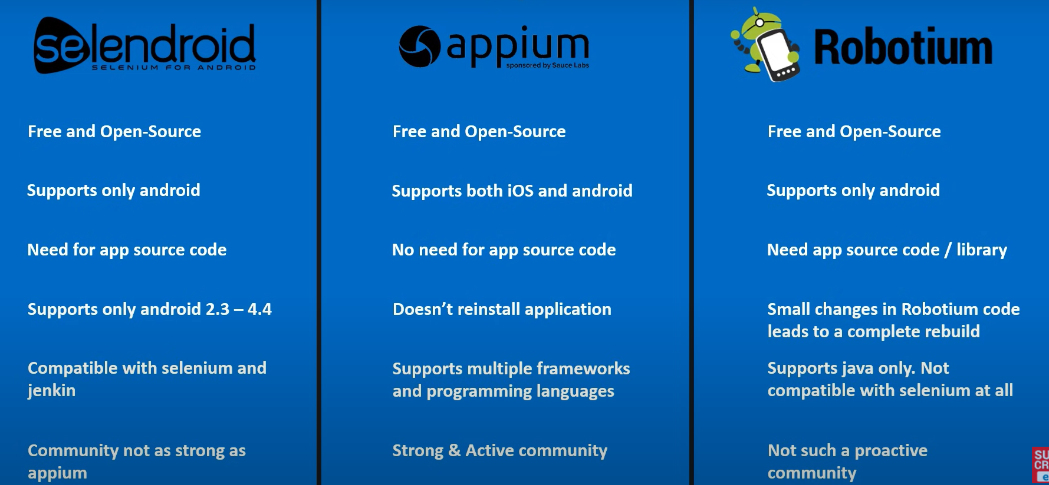

**Appium architecture**

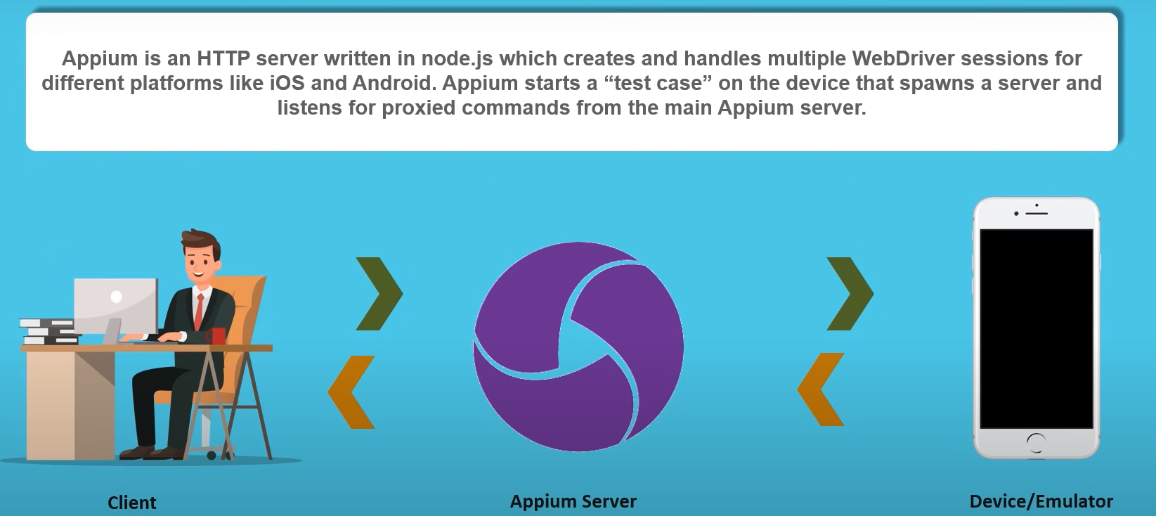

**Appium Design**

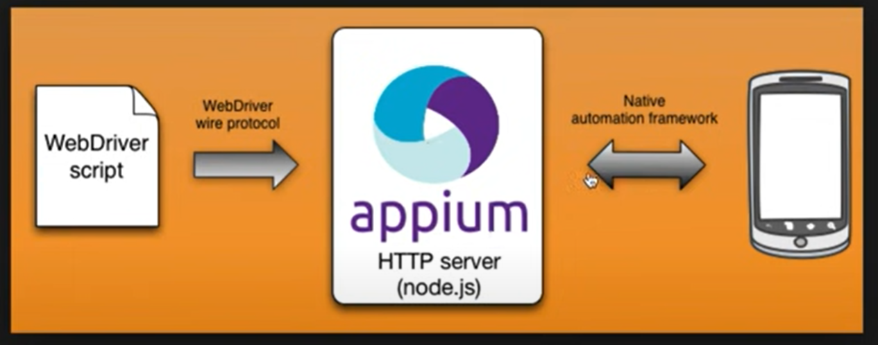

**How appium works on**

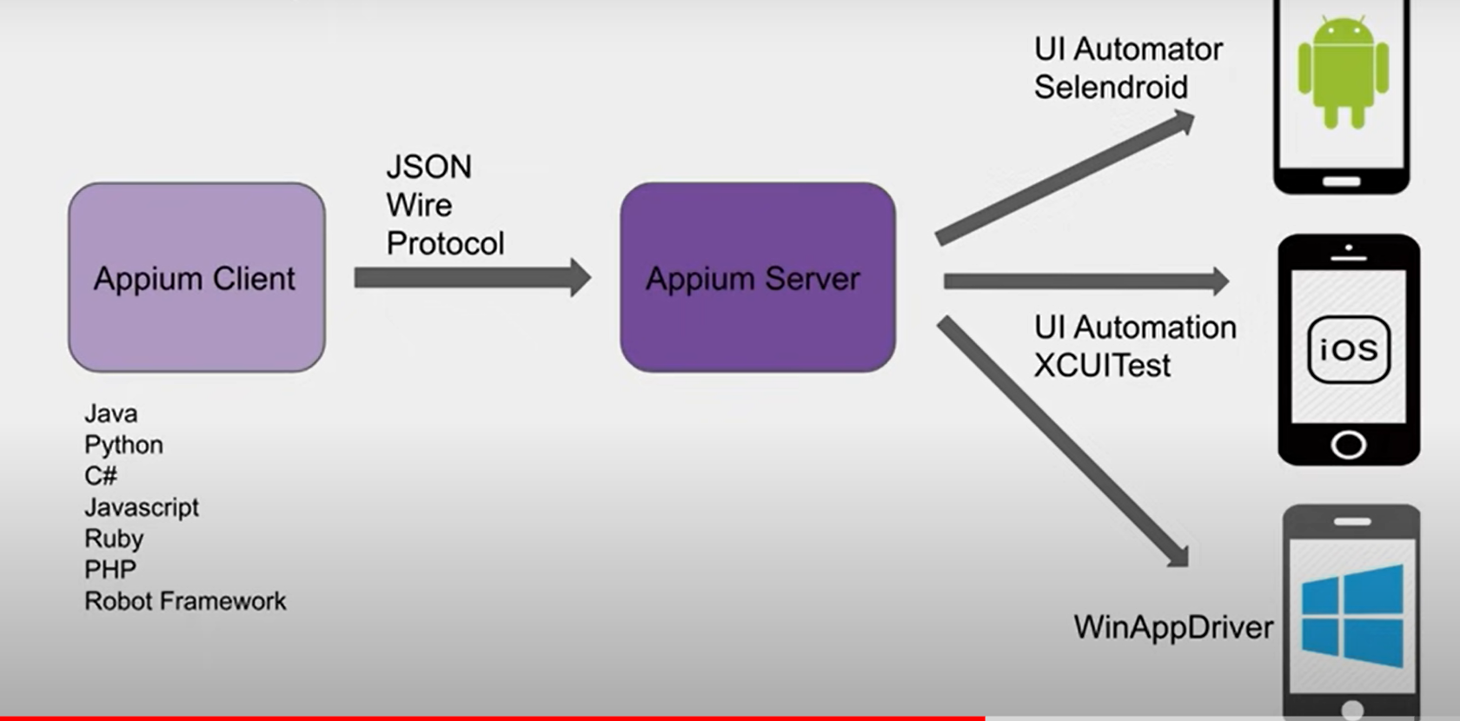

**How web driver works on IOS**

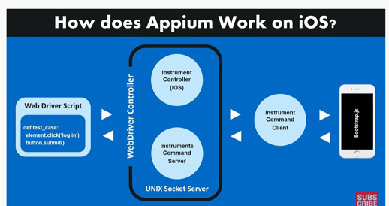

Installing Appium

Installing appium with Node.js

Step 1 : Check if node.js is installed on your system node --version npm --version

Step 2 : Download node.js installer

<https://nodejs.org/en/download/>

Step 3 : Run the installer & install node.js & npm

Step 4 : Check if node.js & npm are installed

cmd prompt:> node --version

cmd prompt:> npm --version

cmd prompt:> node -v

cmd prompt:> npm -v

where node

cmd prompt:> where npm

Step 5 : Install appium with node.js

npm install -g appium

Step 6 : Check if appium is installed

appium -v

where appium

Step 7 : Start appium

appium

**Installing appium with APPIUM DESKTOP CLIENT**

Step 1 : Download appium desktop client

http://appium.io/

https://github.com/appium/appium-desk...

Step 2 : Install appium desktop client

Step 3 : Start appium through appium desktop client

To check appium installation & dependencies

Install appium-doctor

https://github.com/appium/appium-doctor

npm install appium-doctor -g

appium-doctor -h

appium-doctor --android

How to Uninstall appium

Or

Download and install android studio

Add environment variable ANDROID_HOME

Edit the path to add android

Download and install ADB driver

Download and install Appium

Goto appium.io/downloads.html

And install java libraries (java client.jar)

Go to selenium website

Download selenium java (selenium-java-xxxx.jar)

Move the java-client.jar and selenium-java.zip to a separate folder ex dependancies folder and extract it

**Connection real android mobile device on windows**

PREREQUISITES

- Java installed on system

- JAVA_HOME is set in environment variables

command to check : java -version

- An android mobile device

- Connecting cable

- 200 MB to 1 GB of free space

ERRORS

Error Description :

error could not find or load main class com.android.sdklib.tool.sdkmanager.sdkmanagercli

Solution:

using 7zip to extract worked great. Windows zip manager must have an issue when extracting the files

Error Description :

Warning: Could not create settings

java.lang.IllegalArgumentException

at com.android.sdklib.tool.sdkmanager.SdkManagerCliSettings.＜init＞ (SdkManagerCliSettings.java:428)

...(and so on)

Solution:

create folder "cmdline-tools" inside

"android-sdk" folder and cut-paste the "tools" foder into "cmdline-tools" folder. Here is how they relate to each other:

...\android-sdk\cmdline-tools\tools\...

Step 1 : Download SDK tools

https://developer.android.com/studio

----------------------------------------------------------------------------------

Step 2 : Unzip folder & Extract platform tools

----------------------------------------------------------------------------------

Step 3 : Set environment variables

ANDROID_HOME = location of sdk folder

Path : append path of platform_tools folder

----------------------------------------------------------------------------------

Step 4 : Check command adb devices on command line

----------------------------------------------------------------------------------

Step 5 : Make device ready

- enable developer mode

- make USB Debugging on

----------------------------------------------------------------------------------

Step 6 : Connect device to computer system thorugh USB cable

- if asked enable USB Debbugging

----------------------------------------------------------------------------------

Step 7 : Run command adb devices

adb = android debug bridge

Check your device id displayed

**First appium project in java (raghav - tutorial 7)**

Steps

1. Download & Open IDE

2. Create Java Project

3. Add selenium & appium libraries

4. Connect mobile device

5. Start appium server

6. Write code to start a mobile application

7. Use appium desktop client to find element locators

Step 1: Download Eclipse or any other IDE for Java

https://www.youtube.com/playlist?list...

Step 2 : Create a Java project

Step 3 : Add libraries

Selenium java

Appium java client

https://mvnrepository.com/

Step 4 : Connect device

run command : adb devices

Step 5 : Start appium server

can do from command line or appium desktop client

Step 6 : Add code to start automation on mobile device

Set desired capabilities

deviceName

udid

platformName

platformVersion

appPackage

appActivity

http://127.0.0.1:4723/wd/hub

Start calculator application

Step 7 : Run and validate

Troubleshooting tips

(contributed by Flavius-Cristian Luca)

- Issues with getting io.appium.uiautomator2.server.test package info: https://github.com/appium/appium-uiau...

- Original error: 'app' option is required for reinstall: for this, i added the following line of code

desiredCapabilities.setCapability(MobileCapabilityType.APP, "C:\\Users\\＜＜userName＞\\AppData\\Roaming\\npm\\node_modules\\appium\\node_modules\\appium-uiautomator2-server\\apks\\appium-uiautomator2-server-v4.8.3.apk" );

-Error executing adbExec. on Android(M): https://github.com/appium/appium/issu...

**How to use appium desktop inspector to find object locatore (Raghav tutorial 8)**

1. Open Appium desktop client

2. Start appium server

3. Create new connection

4. Provide desired capabilities

5. Start session

6. Tap on objects to view the details

7. Add scripts in project and validate

# How to use UIAutomatorViewer for Object Locators (Tutorial 9)

Step 1 : Connect mobile device to computer system

through cable OR through wifi

https://www.youtube.com/playlist?list...

Step 2 : Run command adb devices

Step 3 : Start UIAutomatorViewer

Windows - goto android-sdk/tools/bin

Mac - from terminal run command uiautomatorviewer

Step 4 : Open the application on mobile device and capture on uiautomatorviewer to find element locators

# How to connect mobile to computer without USB cable through wifi

(Tutorial 10)

Step 1 : Ensure your computer and mobile phone are connected to same wifi network

Step 2 : Connect mobile with computer using cable

Step 3 : On cmd run adb devices. This will list the devices connected

Step 4 : Now on CMD run adb tcpip 5555

You can use any other port also

You should get output like - restarting in TCP mode port: 5555

FREE - https://automationstepbystep.com/onli...

Step 5 : Disconnect mobile cable

Step 6 : Get your mobile ip -

Settings - About Phone - Status

OR

Settings - WiFi - your connected network - and note down the IP address

Step 7 : Run on cmd adb connect ip

adb connect 192.168.1.4

if any issues can do

adb kill-server

adb connect 192.168.1.4

OR

add kill-server

adb connect 192.168.1.4:5555

Step 8 : Now you can use your mobile without cable

Step 9 : To verify run adb devices command and it should list your device

**What is Appium Studio (Tutorial 11 |)**

IDE for appium automation

Enhanced ver of open source appium with a GUI and features

Can develop, execute tests and view test results

Uses Appium/Selenium webdriver api

Created by experitest

https://experitest.com/mobile-test-au...

Features of Appium Studio ?

Easier and faster appium setup

GUI for recording tests, managing devices and apps

All in one tool for appium automation

Parallel execution

CI/CD integrations

Reports integrations

**Tutorial 12 | How to Install Appium Studio on Windows**

Appium Studio

IDE for appium automation

Enhanced ver of open source appium with a GUI and features

Can develop, execute tests and view test results

Uses Appium/Selenium webdriver api

Created by experitest

**Tutorial 15 | How to setup iOS Automation on Mac OS**

Check the steps below

1. Java

2. Appium

3. Xcode

4. Xcode command line tools

5. WebDriverAgent

6. Real Devices OR Simulators

7. IDE (eclipse)

Step 0: Intro 0:00

Step 1: Install Java JDK 0:30

Step 2: Install HomeBrew 1:44

Step 3: Install node js and npm 2:28

Step 4: Install Appium 3:28

Step 5: Install Xcode 3:44

Step 6: Install Xcode command line tools 6:33

Step 7: Create Apple ID 7:06

Step 8: Install Carthage 8:16

Step 9: Initialize WebDriverAgent Project 9:44

For Appium 1.15.0+

https://docs.katalon.com/katalon-stud...

Step 10: Open WebDriverAgent.xcodeproj in Xcode 18:54

Step 11: Build and run project 22:33

Step 12: Create a project and add desired capabilities for automation on iOS 33:22

Detailed Steps - https://docs.google.com/document/d/1H...

If Required To allow Appium permission in MacOS settings ＞security & privacy ＞general

See more: https://support.apple.com/en-in/HT202491

deviceName

platformName

platformVersion

app

Open Eclipse

Create a new maven project or use any existing maven project

Add maven dependencies

appium

selenium

DesiredCapabilities cap = new DesiredCapabilities();

cap.setCapability("platformName", "iOS");

cap.setCapability("platformVersion", "11.4");

cap.setCapability("deviceName", "iPhone 8");

cap.setCapability(CapabilityType.BROWSER_NAME, "safari");

cap.setCapability("app", “location of .app or .ipa file“);

URL url = new URL("http://127.0.0.1:4723/wd/hub");

IOSDriver driver = new IOSDriver(url, cap);

**Tutorial 16 | How to create iOS automation testing project in java**

Step 1 : Open IDE (eclipse) 0:30

Step 2 : Create a new maven project or use any existing maven project 0:50

Step 3 : Add maven dependencies 2:15

appium java client : 2:38

selenium java 3:18

Step 4 : Create a class and add desired capabilities for automation for iOS 4:01

1. IDE (Eclipse)

2. Appium java library

3. Selenium java library

4. Desired Capabilities

5. iOS device or simulator

by: Raghav Pal

http://appium.io/docs/en/writing-runn...

deviceName

platformName

platformVersion

app

DesiredCapabilities cap = new DesiredCapabilities();

cap.setCapability("platformName", "iOS");

cap.setCapability("platformVersion", "11.4");

cap.setCapability("deviceName", "iPhone 8");

cap.setCapability(CapabilityType.BROWSER_NAME, "safari");

cap.setCapability("app", “location of .app or .ipa file“);

URL url = new URL("http://127.0.0.1:4723/wd/hub");

IOSDriver driver = new IOSDriver(url, cap);

/Users/raghav/Library/Developer/Xcode/DerivedData/WebDriverAgent-brdadhpuduowllgivnnvuygpwhzy/Build/Products/Debug-iphonesimulator/IntegrationApp.app

To get device id

npm install -g ios-deploy

ios-deploy -c

OR

instruments -s devices

Step 5: Run and Test 12:50

#AppiumBeginnerTutorials

http://bit.ly/2W9pNeb

if anyone is facing the below issue when trying to use instruments -s devices: then below solution would help you guys:

Xcode: xcode-select: error: tool 'xcodebuild' requires Xcode, but active developer directory

'/Library/Developer/CommandLineTools' is a command line tools instance

Solution is :

In the terminal execute the below line:

sudo xcode-select -s /Applications/Xcode.app/Contents/Developer

And then try with the command:

instruments -s devices

Reference - <https://github.com/meteor/meteor/issu>...

**Appium Automation Framework from scratch | Java | Maven | TestNG**

What we will do:

1. Create a java maven project in eclipse

2. Add required libraries

3. Create classes and functions

4. Add desired capabilities

5. Setup mobile device and appium

6. Create tests for mobile test automation

7. Run and test

Prerequisites:

1. Java JDK -https://www.youtube.com/playlist?list...

2. Appium is installed

3. Android sdk is setup (for testing on android )

4. Xcode is setup (for testing on iOS)

5. Mobile device is ready for automationhttps://www.youtube.com/playlist?list...

6. Eclipse is installed

Intro - 0:00

Step 1 : Open Eclipse 3:40

Step 2 : Install TestNG in eclipse https://youtu.be/yyUyi8s42dE

https://youtu.be/AzVyetnW3hU

Step 3 : Create a new maven project 5:20

Step 4 : Add required lib/dependencies 7:31

Appium java client 8:40

Selenium java 9:50

TestNG 10:20

Step 5 : Save - Clean - Build project 12:00

Step 6 : Create 2 folders under src/test/java 12:20

tests

pages

Step 7 : User src/test/resources create a folder 14:00

apps

will keep application files (.apk, .ipa, .app)

Step 8 : Inside tests folder create a class - BaseClass 15:15

Step 9 : Create setup & teardown functions 16:00

Annotate with testng annotations

Step 10 : Add code for desired capabilities 18:25

Step 11 : Attach mobile device (or make emulator ready) 25:50

adb devices

get id and platform ver and add in desired capabilities

Step 12 : Start appium server 29:00

Step 13 : Run & test 35:55

Step 14 : Add test class and extend BaseClass 39:05

Appium Automation Framework from scratch

Eclipse Java Maven TestNG

Step by Step

Can follow on Windows & Mac

